### Case Study: Security Investigation with Microsoft Sentinel and Jupyter Notebooks

Vanguard Invest implemented **Jupyter Notebooks** by following this structured approach:

1. **Setting Up Microsoft Sentinel and Notebooks Integration**

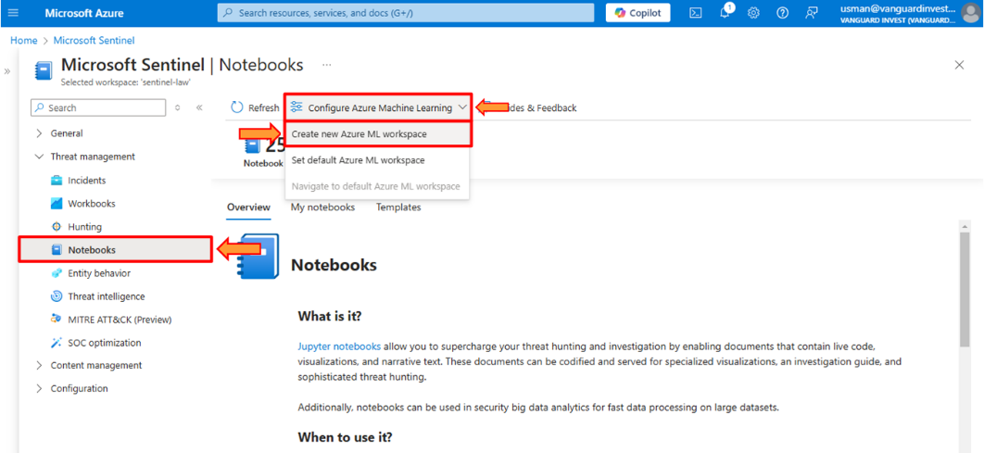

1. **Deploying Pre-Built Notebooks**

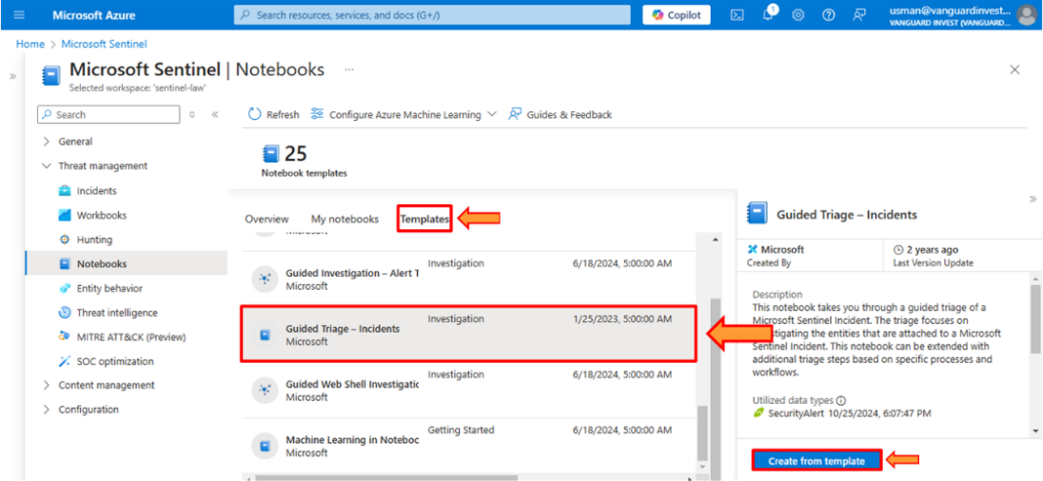

1. **Enhanced Threat Investigation with MSTICPy**

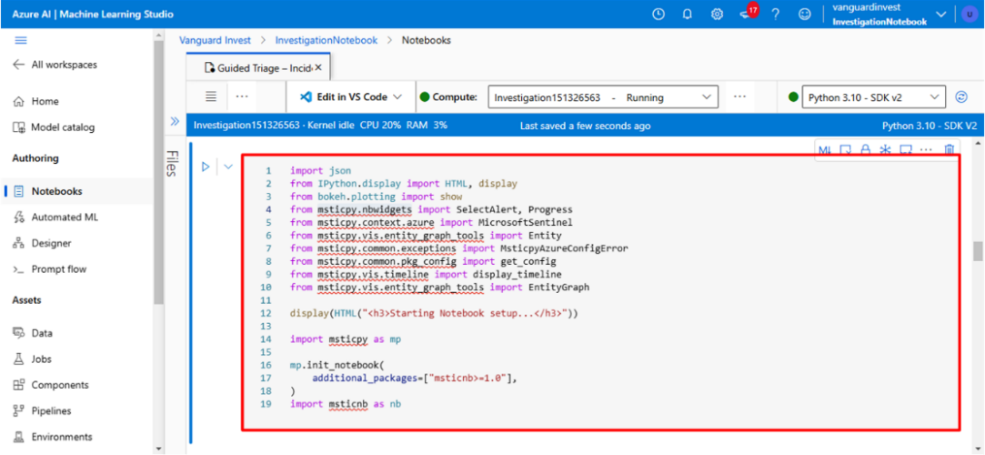

1. **Automated Playbooks and Real-Time Reporting**

